Department of exercise science – MOtor control and rehabilitation
Functioning of the “Chattanooga ionto” dual channel electrophoresis system
Chaitali Anand
8/18/2010

This short lab manual will serve as a guide to using the Chattanooga device for tDCS when working with human subjects.

Functioning of the 'Chattanooga ionto' Dual Channel Electrophoresis System

Background:Transcranial direct current stimulation (tDCS) is a non-invasive and painless procedure to modulate brain functionand does not elicit any substantial side effects. The current is applied with two sponge-electrodes over the scalp. The most common reported side-effects are a mild tingling or mild burning at the area under the electrodes during the stimulation.
Purpose: The Chattanooga ionto dual channel electrophoresis system – a device less than the size of one’s palm, is portable, low-cost, user-friendly and reliable and is capable of delivering a currentthat can be set in 0.1 mA (milliampere) increments between 0.5 mA and 4 mA. It can deliver currents up to dosages of 160mA-min.
Principle: The principle of tDCS is based on affecting neuronal excitability and modulating the firing rates of individual neurons by a low amplitude direct current which is delivered non-invasively, painlessly and safely through the scalp. This treatment is delivered to specific selected brain structures (Nitsche and Paulus, 2001). The effect of tDCS depends on the polarity – anodal or cathodal. Anodal tDCS of the human motor cortex enhances the cortical excitability due to neuronal depolarization.Cathodal tDCS, on the other hand, can induce prolonged reductions in excitability of the human motor cortex by hyperpolarizing the cortical neurons.
Scope:This write-up will serve as a guide to using the Chattanooga device for tDCS when working with human subjects.

Materials:The basic materials required are a constant current stimulator and surface electrodes. The individual components of the Chattanooga ionto dual electrophoresis system used here are the electrophoresis device, 9 volt battery, lead wires, electrodes (area about 25cm²) with rubber cushioning, sponges, self-adhering tape, wound-wash saline, scale and protractor.
self-adhering tape

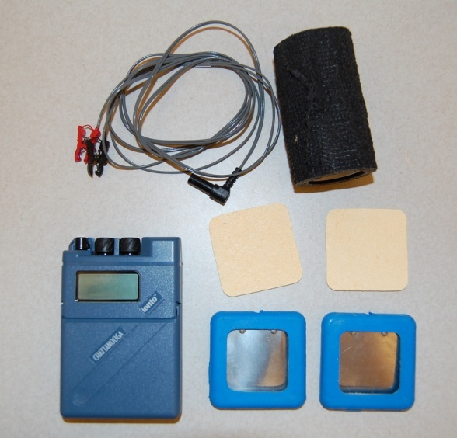
sponges
lead wires
device
electrodes

Definitions and Terminology:
Two current knobs control the current output through channels 1 and 2 (between 0.5mA and 4mA)
S1 - align knob to S1 to change target dose settings of channel 1
S2 - align knob to S2 to change target dose settings of channel 2
P - Pauses the output during treatment allowing you to check the treatment area and progress without having to restart the session
R - Run mode to initiate/resume treatment
The Power button under the flap switches the device on/off. The display button selects what is to be displayed (time, dose or current), and the dosage button increases/decreases current dose (mA/min).
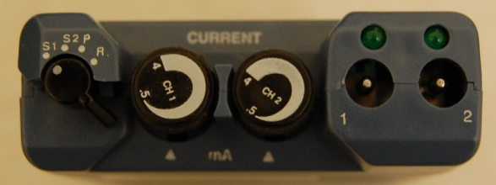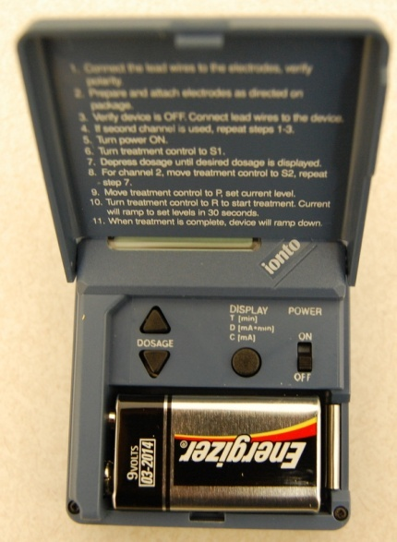
battery
dosage
power
channel 1
S1, S2, P, R
display
channel 2

Safety: It is advised to connect the lead wires to the electrodes first and then fix the electrodes to the area to be treated. The lead wires are then connected to the device before turning the device on. Before detaching the electrodes from the subject’s body, make sure the current has completely gone down and the power is switched off. If detached during a running current, the subject may experience a flash across their eyes.
Operating Procedure: Wet the sponge pads with saline solution to inflate them. Squeeze out any excess fluid but at the same time make sure the sponge is sufficiently wet.Saline helps conductance. Insert the wet sponge in the blue rubber-padded electrodes.
Insert a 9-volt battery in the device. Connect the lead wires with black and red ends to the metal surface of the electrodes. Make sure that there is proper contact between the two metal surfaces (of the electrode and the wire clip); else the current will not flow.
Turn power on. Using S1, adjust dosage (for example: for a 1mA current running for 20 minutes, adjust dosage to 20mA-min). Then turning the knob on P and using therespective knob for channel 1 or 2 adjust time (example: 20 minutes) and current (example: 1mA). The recommended and safedosage has been found to be 20 mA-min (Iyeret al, 2005). Use S2 only if channel 2, i.e. the outlet for a second set of electrodes, is to be used as well.
Place the anodal (red clipped) electrode on the target scalp area and secure it with a self-adhering tape. Similarly place the cathodal (black clipped) electrode on the contralateral shoulder of the subject and secure that as well. This serves as ground.
Connect the lead wires to the device after the electrodes have been secured on the stimulation sites.
Make the subject aware of the tingling or itchy feeling at the point on the scalp where the current will be applied. Turn the knob to R when the subject starts taking the test. After the test ends (here, 15 minutes) turn the knob to P to stop current flow.
Make sure that the current returns to 0 before taking off the electrode plates from the subject's head/shoulder/etc. Low power, abrupt detachment or incomplete contact causes the device to beep.
If sham treatment is to be used, turn knob back to P a minute after starting the current. It has been found out that the sensations produced by tDCS fade away 30 seconds to a minute after initiating the current due to tolerance (Schlaug and Renga, 2008). This allows the device to operate in sham mode.
Troubleshooting: Make sure the 9 volt battery in the device works; else replace it with a new one. The device will beep when power supply is insufficient. If the device shuts down during treatment, record how much of the treatment was completed and then continue after restarting. Incomplete conduction may occur due to insufficient saline on the sponges.
Telephones/mobile phones should preferably be switched off or kept away during the stimulation. This avoids distraction to the subject while performing the test.
The researcher should clean and dry the skin of the subject where electrodes will be placed. It is also advised to confirm the polarity of the electrodes (anode or cathode) before proceeding with the stimulation.
Make sure that the participant has no metal on his/her head (for example: metal head bands)

A brief overview of how transcranial direct current stimulation (tDCS) works:
The immediate short-lasting effects of tDCS may be due to shifts in polarity in the cell’s membrane potential. The excitatory effect of anodal stimulation is believed to result from the depolarization of membrane potential causing action potentials to discharge more readily, whereas the inhibitory effects from cathodal tDCS is believed to result in the opposite effect, i.e. hyperpolarization. Cathodal stimulation decreases the MEPs. Anodal polarization of motor neurons increases potential difference across the nerve sheath, the amplitude of response to the stimulation, and the duration of the spike. tDCS does not directly cause resting neurons to fire; rather, it modulates the spontaneous firing rate of neurons by changing polarity of membrane potential⁹⁻¹¹. The long-lasting effects of tDCS may be due to an involvement of synaptic mechanisms, viz. N-methyl-D-aspartate (NMDA) receptors, an amino acid that mimics the action of glutamate, an excitatory neurotransmitter (Nitsche et al, 2003) .
10-20 minutes of tDCS over the motor cortex can lead to an increase in excitability upto 150%, lasting for around 90 minutes. Anodal tDCS examines whether the performance of a particular sensorimotor or cognitive function linked to the stimulated brain can be enhanced temporarily. Effects of tDCS are region specific and may be related to the orientation of the fibers connected to the stimulated region (Schlaug and Renga, 2008).
References:
Drummond SP, Bischoff-Grethe A, Dinges DF, Ayalon L, Mednick SC, Meloy MJ (2005) The neural basis of the psychomotor vigilance task. Sleep28(9):1059-68.
Iyer MB, Mattu U, Grafman J, Lomarev M, Sato S, Wassermann EM (2005) Safety and cognitive effect of frontal DC brain polarization in healthy individuals. Neurology64(5):872-5.
Nitsche MA, Fricke K, Henschke U, Schlitterlau A, Liebetanz D, Lang N, Henning S, Tergau F, Paulus W (2003) Pharmacological modulation of cortical excitability shifts induced by transcranial direct current stimulation in humans. J Physiol 553:293-301.
Nitsche MA, and Paulus W (2001) Sustained excitability elevations induced by transcranial DC motor cortex stimulation in humans. Neurology (57) 1899-1901.
Schlaug G, and Renga V (2008) Transcranial direct current stimulation: a noninvasive tool to facilitate stroke recovery. Expert Rev Med Devices 5(6) 759-768.

